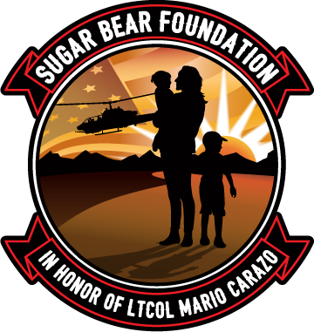

A2Z Healing Toolbox Application
with Susan Hannifin-MacNab
To Apply, please send the following Required Documents to Admin@thesugarbearfoundation.org (if not already on file):
- Sugar Bear Foundation Gold Star Registry Application
- Attach a copy of the DD1300 or other proof that you are receiving benefits due to your spouse’s death from military service (PDF Files or legible photos are acceptable). You cannot move forward in this process without submitting your DD 1300 as well as signing the waiver.
- This A2Z Healing Toolbox Application
- Waiver and Release Form
*Acceptance of this program is based on our budget and the availability Susan Hannifin-MacNab.

Applicant Name: Click or tap here to enter text.
Physical Address: Click or tap here to enter text.

Mailing Address: Click or tap here to enter text.

Phone Number/s: Click or tap here to enter text.
Email: Click or tap here to enter text.
Why do you want to work with Susan Hannifin-MacNab?
Click or tap here to enter text.

Please provide us with an anonymous statement (one to two sentences) that we can share with our donors and explain what this scholarship/grant means to you/your family? How does it help?

Click or tap here to enter text.

Signature: __________________________________________________________

Date: _______________

